**Puzzle Feature List**

This is a list of features, tools, and/or mechanics that we would like to see included in the game. These features will allow us to create a series of puzzles. While the puzzles may interact at some point, the features can hopefully be developed independently of each other. As such, there is no requirement to ensure compatibility.

We have divided puzzles into three types: sequence, combination and pressure puzzles. All of them together emphasize the wheel+trigger interaction scheme we have been building so far.

* In sequence puzzles, players have to play a sequence of tones within a time frame or in a certain order to proceed. Emphasis is on range of sequences using individual tones in an order such as with playing the correct melody or moving a platform in a direction using one tone.
* In combination puzzles, players have to deduct the right combination of tones using the chord mechanic in order to proceed. Emphasis is on game checking for tones to be correct within the context of the individual puzzle.
* In pressure puzzles, players have to use the trigger sensitivity to control certain parameters in the world using the analog input of R2.

**Misc. feature list**

* **Wheel Tweaks:**
  + When the analog stick enters its dead-zone, the wheel will currently instantly despawn. This makes it so the wheel disappears when the player goes past the dead-zone. There should perhaps be a delay before the wheel despawns, so that the player can pass it safely.
  + When play stops using analog stick but maintains note by holding L2/R2, the note continues to play until button is released.
  + The last used chord/tone should always be played when the player hits L2/R2.
* The ability for certain objects to emit sounds. Sounds like footsteps and collision, but also playback sounds made by the player. For example: player sings ‘A’, object sings back ‘A’.
* A “soft reset” function to act as a setback for player failure.
  + For example: player falls into hole, screen fades to black, then “resets” scene.
* Pressure plates: when object A collides with, is in top of, or presses down object B, effect X is produced.
* Different colored light sources.

**Sequence puzzles**

* Time sensitive activation of notes. For example, after singing/activating ‘A’, the player has 3 seconds to input the next note.
* Wheels and other objects that display colors (notes), rotate, and move according to player input. For example, playing the green note makes the wheel rotate once.
* Example: a template platform where the designer can use the inspector to specify what notes to “listen for”, in what order, and with how much delay/time interval.

**Combination puzzles**

* Available notes are mapped from 1 to 6. Certain objects in the world can generate a random number (note). Player is then required to play back two different notes: either higher, lower or both numerically. This procedure needs to be repeatable (that is, multiple rounds of receiving a note and playing back two others).
* Chord interactions: Singing a chord activates the individual notes as well. For example: Singing ‘AB’ will activate effects of both ‘A’ and ‘B’.

**Pressure puzzles:**

* Light source radius dependent on trigger pressure. For example: fully pressing triggers lights up the room completely. Releasing the trigger makes light slowly fade to initial brightness level.

**Level idea:**

* 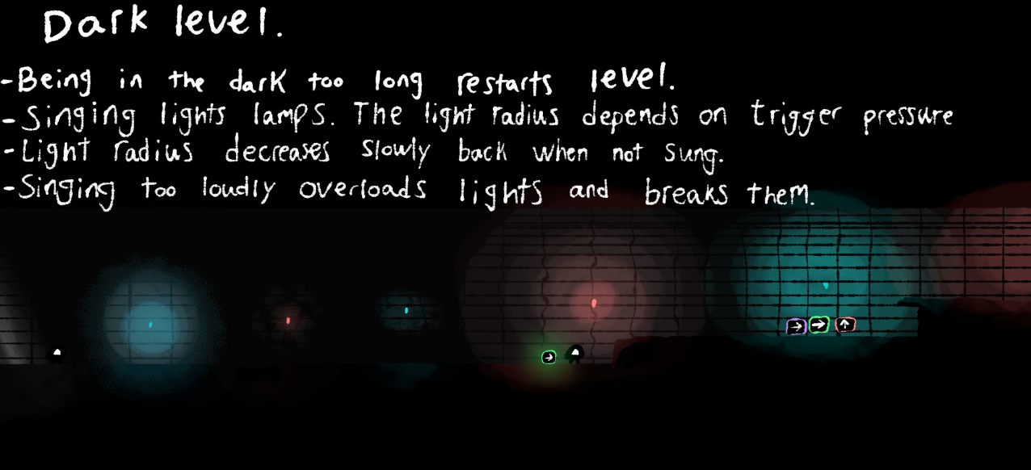
* Controlling audio playback/tempo and object rotation/movement with trigger pressure.
  + For example: turning wheel with triggers alters playback speed. Movement of other objects depend on same parameters.

**Level idea:**

Using pressure sensitivity to adjust rhythm of song, and through this the speed of the obstacles in the world. In this example, you’d have to adjust the speed of moving obstacles as the floating platform flies you to safety.

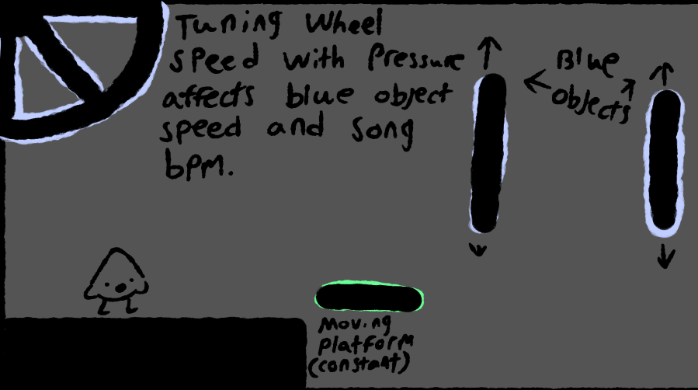

* Attracting and repelling (that is, moving) objects with velocity dependent on trigger pressure.
  + For example: gently pulling triggers slowly brings objects closer. Harshly pulling triggers does so faster.

**Level idea:**

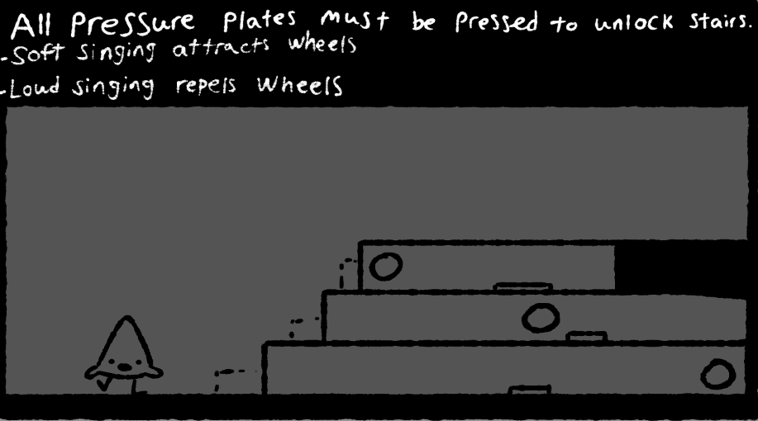

* Time sensitivity: sustaining “loud” (that is, fully pressed triggers) for a certain amount of time can produce effects.
  + For example: singing loudly for five seconds will shatter a wall of glass.